Air Bypass Idle

There are three types of air bypass motor. 2 wire push/pull, 3 wire push/pull, and stepper motor.

Option ‘Idle Duty Max’ is the duty cycle above which the idle motor does not flow extra air.

Option ‘Idle Duty Min’ is the duty cycle below which the idle motor does not flow any air.

The Idle Duty Coolant table gives the % opening of the idle motor required at each temperature to achieve the base target idle.

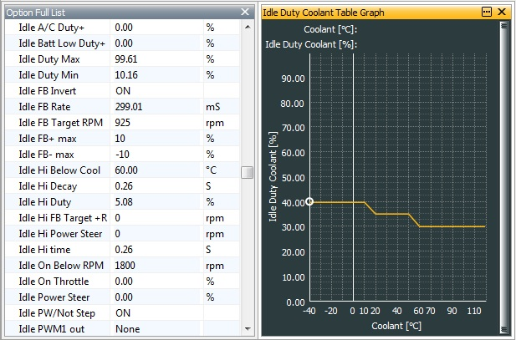

The Idle Duty RPM table is a modifier based on engine speed, looking to see if engine speed moves below the target idle, so acting as an anti-stall feature. The target idle speed should have a modifier of 0. Engine speeds well below target should have a large positive number to open the idle motor to stop the engine stalling.

The idle is then fine-tuned and maintained by the feedback loop. Idle FB- max and Idle FB+ max are the feedback limits for the idle motor. The update rate of this feedback loop is set by Idle FB Rate. This would typically be 40ms with a stepper motor or 200ms with a PWM device. The Idle Fuel table is required for engines that are using air bypass with throttle position as the main load sensor. On TPS load based engines, the ECU does not measure the extra air flow due to the opening of the idle motor, so does not compensate with extra fuel in the main fuel map to maintain the target lambda (air/fuel ratio). An oxygen sensor cannot make adjustments to the fuelling fast enough to cope with these changes. This table allows a fuel trim based on idle motor duty to maintain a constant lambda value. This is not required for MAP or MAF based systems.

