Connecting the PC to the ECU using either serial link or USB is referred to as going ‘on-line’. Once on-line, calibration data is automatically downloaded from the ECU if necessary and parameter data can be viewed. Some GWv4 functions, such as PC logging and auto mapping, can only be used when on-line.
If you are connecting to an ECU for the first time then you will need to adjust your connection settings.
If your ECU uses a different connection port from the previous port used (e.g. you are connecting via a USB connection instead of a serial cable) then you will also need to adjust your connection settings.

If you are having connection problems not covered by this topic, see the Connection Problems below.

Establishing a Connection
Once your connection settings have been set, you are ready to connect to the ECU. Connect the USB or Serial cable to the PC and the ECU. Check that the correct port is selected in your connection settings.
Now click the connect icon on the tool bar or select ECU | Connect from the main menu.
Alternatively you can choose to upload a calibration which will connect to the ECU then upload the calibration to it. To do this, select ECU|Upload New/Current Calibration from the main menu. If you choose just to connect, the calibration that is stored in the ECU will be downloaded and displayed.

Generally, it is best to click on ECU | Connect and then supply power to the ECU to avoid connection failures due to the ECU entering telemetry mode (see Trouble shooting section for more details).
When connecting, a window will be displayed showing the progress of the requested operations:-
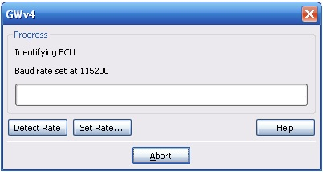
If you are connecting to your ECU using a serial connection, you can get GWv4 to detect the Baud Rate by clicking on the "Detect Rate" button. If you know the baud rate for your ECU then you can use "Set Rate" to configure it manually. The help button should bring you to this page.
When you are online, verification will be displayed in the status bar at the bottom right of GWv4:-
You will notice that when GWv4 is connecting the ECU Status Window will display briefly. This will show information about communication operations that are being performed between the PC and the ECU. This can be useful for diagnosing connection problems.
Once connected, GWv4 will load the ECU definition file (GIN) for the connected ECU. If a .GIN file has not yet been installed for your ECU, then a search will be performed and the .GIN file installed:-
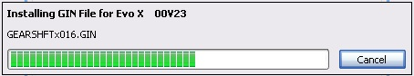
This will search the GWv4 definitions folder for any GIN files shipped with GWv4. If you have had a previous installation of GWv3 then the GIN files folder for GWv3 will also be searched.
If a suitable GIN file cannot be found then you will be offered to run the ECU Installation Wizard. GIN files can also be downloaded from the GEMS website or on request from tech.support@gems.co.uk.
Connection Problems
There can be many causes of connection problems but most common causes are usually straight forward and easy to solve:
· | Does the ECU have power?

· | Is the cable connecting the ECU to the PC securely attached?

· | Have you selected the correct port in your connection settings?

· | Are you using the correct baud rate?

Telemetry Stream Mode
Some ECU's use the serial port for telemetry output in addition to providing a connection for the PC.
Such ECU's will start streaming telemetry data from the port a short time after the ECU has been powered on. If ‘telemetry streaming’ has occurred, power-cycle the ECU while GWv4 is attempting to connect to it.

It helps to have the correct baud rate set in these circumstances, since using the automatic baud rate detection can take a while and the ECU may enter into telemetry stream mode before the correct baud rate has been found. You can set the baud rate directly from the connect progress dialog or in the Advanced tab of connection settings.

Cannot Open Port
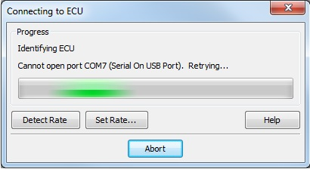

This suggests that the port cannot be opened due to one of the following situations:
1) It is plugged into a different USB port and it is no longer on COM7.
To resolve this, go to ECU > Connection Setup and Select the appropriate port. Then go to the ECU tab and click Connect to try the Connect icon.

2) The port is in use by another application.
Applications cannot usually share serial ports, so close all other applications that could be using it. Maybe also try temporarily disabling your virus scanner in case this is the cause of the conflict.

3) The port is in use by a program that recently crashed.
Reboot the system and try again.

USB to Serial adapters
USB to serial adapters vary significantly and some products do not work well with GWv4. We have found that ATEN adapters tend to work well and we can supply these to you on request. If you are having trouble connecting with a USB to Serial adapter try using a different USB port on your PC. This sometimes resolves problems, particularly on laptop PC's running off the mains electricity supply.

Sometimes the USB connector does not make good contact with the socket. A small squeeze of the connector on the cable with your thumb can sometimes improve things. This is only necessary if the PC cannot see the adapter at all (it does not appear in the windows Device Manager).

What else can I try?
Check that there is sufficient battery voltage to the ECU. This is generally 12 volts. If your battery voltage is low, then you may experience comms drop-outs or no comms at all.

Is there sufficient protection from electrical noise on your connection cable? Can you connect when the ECU is powered but the engine is not running?

Check the communications cable using a continuity tester or multi-meter. In particular, test the TX and RX lines between the ends of the cable.

For serial connections on a laptop PC, try a PCMCIA serial adapter if possible.

Open the Comms Monitor Window to check if data is being sent by the PC and being returned by the ECU. Requests from the PC are displayed in blue text and responses from the ECU are displayed in red. You should see a red response for every blue request.

Check the ECU Status Window to see if there have been any errors.

Further Connection Problems
I get a blue screen or a reboot when using the connection setup window. This is due to a bug in driver software. Try bringing up Windows(r) Device Manager and checking if you have a "Soft Data Fax Modem" under the "Modems" item. If you do, this is known to have caused problems in the past but recent editions of GWv4 have a workaround that should avoid the problem.
Solution:- Right click the item and select 'Disable'.

See the Driver Installation section for details on how to get to Device Manager.
If the ECU is an X25, it could also be due to the driver. If this is installed then please try removing it and connect using a serial port instead.

It could also be due to a conflict with the LEGO Mindstorms driver.
This issue will be tackled in future releases of GWv4. For now, the only solution is to remove the libusb filter driver which will require some software. The ordinary driver should be OK.

