SYNCHRONISATION STRATEGY

There are 4 synchronisation strategies and only one may be active at any one time.

1. Sync Crank S count
Sync Crank S Count is for the cam/crank patterns that have evenly spaced teeth on the crank position sensor trigger wheel with no missing teeth, but has more than one tooth on the cam position sensor trigger wheel. Since there's more than one cam tooth, we can't use Sync Cam Count as it would try to sync in multiple spots. When Sync Crank S Count is selected, the number of crank tooth signals will be counted between each of the cam tooth signals.

i) SS Tooth No = MX Sync test and Sync Tooth = Sync teeth
ii) SS Tooth No is the number of internal crank teeth between cam teeth.
iii) Sync tooth is the value of Fuel tooth at the synchronising cam tooth.

Example 1
Honda S2000 24 even crank teeth per engine cycle with 3 cam teeth at TDC for only 3 cylinders.
So: Tooth Control table is 0-23 = 5, 24 = 3
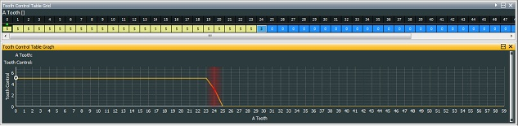
Sync Cam Count = OFF, Sync Crank S Count = ON, Sync MX = OFF
Sync Teeth = doesn’t matter. (See parameter Sync Tooth or Cam tooth1, the cam tooth for synchronisation relative to crank), MX Sync Test = 12 (see parameter SS Tooth No, the number of internal teeth between cam teeth at the synchronising cam tooth). The other possibility 6 is not unique as it occurs twice per engine cycle.

Example 2
Toyota 24 even crank teeth per engine cycle with 1 cam tooth.
So: Tooth Control table is 0-23 = 5, 24 = 3
Sync Cam Count = Off, Sync Crank S Count = On, Sync MX = OFF
Sync Teeth = 1, MX Sync Test = 24

Example 3
Simple crank trigger edge at 45deg 4 teeth cycle, no cam synchronisation.
So: Tooth Control table is 0-2 = 1, 3 = 5, 4 = 3
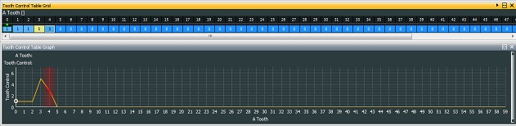
Sync Cam Count = Off, Sync Crank S Count = On, Sync MX = OFF
Sync Teeth = 0, MX Sync Test = 4. Adjust option Ignition range for useful +/-45 degrees = 0.5

2. Sync Cam Count
This is the simplest synchronisation strategy. It is for cam/crank patterns that have equally spaced teeth on the crank position sensor trigger wheel, no missing teeth, and one tooth on the cam position sensor trigger wheel. What the EM36 does, is look for the first crank tooth signal that occurs after the cam tooth signal as a reference point for the engine position.

Example 1
Toyota 24 even crank teeth per engine cycle with 1 cam tooth.
So: Tooth Control table is 0-23 = 5, 24 = 3
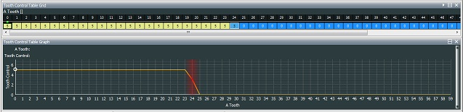
Sync Cam Count = ON, Sync Crank S Count = OFF, Sync MX = OFF
Sync Teeth = 1, MX Sync Test = 24

Example 2
For an old Subaru with 3 crank teeth per cylinder event.
So: Tooth Control table is 4,5,6, 4,5,6, 4,5,6, 4,5,6, then at 12 = 3
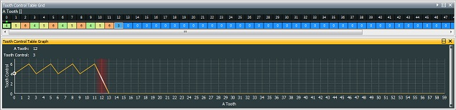
Sync Cam Count = ON, Sync Crank S Count = OFF, Sync MX = OFF Sync Teeth = 1 or 3 there are two 2s, MX Sync Test = 12. Note Ignition range = 0.50 teeth, and Crank Alt Fire = ON, Start Ignition = -10

3. Sync MX
This signifies a ‘Missing Tooth’ strategy. Tests are performed when a missing tooth is detected.
The detection point will be just before a ‘reset’ (value 3 in [Tooth Control] table), being either a “4” or “5” to check for synchronisation. The tooth may be used as an ‘internal tooth’, where option MX Sync test = MX count and option Sync teeth = Cam Tooth Count.

If option Sync Test Last is set to ‘On’, then the previous synchronisation tooth count test will have captured Cam Tooth Count and saved it in Cam Tooth Last Count. This too must match option Sync Last Count. This will give added security and allow synchronisation with Nissan 350Z.

i) MX Count is the number of normal crank teeth between missing teeth.
ii) Cam Tooth Count is the number of cam teeth in the same interval.
iii) Missing is the number of successive missed teeth. If negative the system searches for early or extra teeth.
iv) MX Time is used to make d Tooth Time. It is compared with the parameter Tooth time to detect the missing (or extra) tooth. If detected it is displayed in parameter Miss Time.
v) MX Time Start is used to make d Tooth Time when in start mode. It is compared with the new Tooth time to detect the missing (or extra) tooth. If detected, it is displayed in Miss Time. If left as ‘0’, it will not be used.
vi) If option Test Not Sync'd is ‘On’, there only needs to be a check for crank synchronisation rather than locate it. This allows for less “4”’s in table and this will reduce processor work load.

Example 1
Bosch (60-2, 60 with 2 missing) 58 crank teeth at 6 degree intervals on crank with 1 cam tooth.
So: Tooth Control table is 1,0,0,0,0 repeating from 0 to 49 then 1,0,0,4,4,5,4,4,3, the string of sync tests to find missing teeth at end.
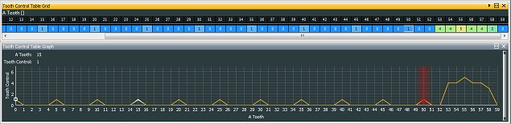
Option Test Not Sync'd must be set to ‘On’ so that while cranking, all opportunities are used for timing synchronisation. The initial section acts as a ‘divide by 5’, so that ‘internal tooth’ scaling is 1 tooth = 30deg. The final section (53-58) is looking for the missing teeth.
Sync Cam Count = OFF, Sync Crank S Count = OFF, Sync MX = ON, Sync Teeth = 1, MX Sync Test = 57, MX Time = 75%, Missing = 2

Example 2
Ford (36-1) 35 crank teeth at 10 degree intervals on crank with 1 cam tooth.
So: Tooth Control table is repeating 1,0,0,1, till 30 then 4, 4, 5, 4, 3
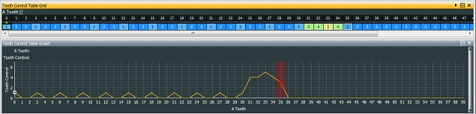
The initial section acts as a divide by 3 so that internal tooth scaling is 1 tooth= 30deg. The final section is looking for the missing teeth.
Sync Cam Count = OFF, Sync Crank S Count = OFF, Sync MX = ON, Sync Teeth = 1, MX Sync Test = 34, MX Time = 75%, MX Time Start = 50%, Missing = 1. Test Not Sync'd must be set ‘On’, so that while cranking, all opportunities are used for timing synchronisation.

Example 3
Toyota (36-2) 34 crank teeth at 10 degree intervals on crank with 1 cam tooth.
So: Tooth Control table is repeating 0,0,1, till 29, then 4,4,5,5,3
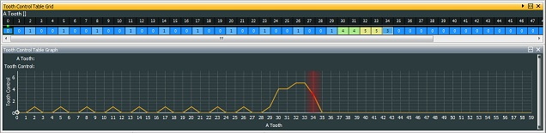
The initial section acts as a divide by 3 so that internal tooth scaling is 1 tooth= 30deg. The final section is for checking for the missing teeth.
Sync Cam Count = OFF, Sync Crank S Count = OFF, Sync MX = ON, Sync Teeth = 1, MX Sync Test = 33, MX Time = 50%, Missing = 2 Test Not Sync'd must be set to On, so that while cranking all opportunities are used for timing synchronisation.

Example 4
An old Mustang. 7 normal teeth, one short tooth.
So: Tooth control table is 5 and 6 repeating until tooth 16 which is set to 3.
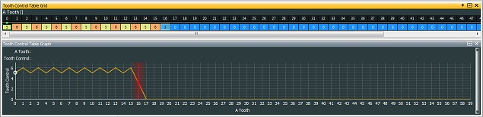
Both edges are required for Crank Alt Fire. Sync Cam Count = OFF, Sync Crank S Count = OFF, Sync MX = ON, Sync Teeth = 0 there are no cam teeth, MX Sync Test = 15, MX Time = 66%, Missing = -1 an early tooth after 15 normal transitions.

If operating with the OEM distributor, Spark Teeth or Ignition Cycle Teeth must not be 1, since there would be no opportunity to update firing information. The solution is to assign 2 spark outputs offset by 1 tooth, so Spark Teeth or Ignition Cycle Teeth = 2

Example 5
New Honda 12+1 as on Type-R. 12 normal teeth one extra tooth. A favourite.
So: Tooth control table is 1 repeating until tooth 9 then three 5s, a 4 and finally 3.
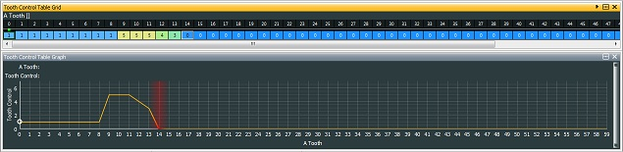
Sync Cam Count = OFF, Sync Crank S Count = OFF, Sync MX = ON
Sync Teeth = 2 or 3, MX Sync Test = 11 (the value in MX Tooth No), MX Time = 33% and Missing = -1, an early tooth after 12 normal transitions. Test Not Sync'd must be set to ‘On’, so that while cranking all opportunities are used for timing synchronisation.

Example 6
New Subaru (since 2002) 4 Cylinder pattern has 36 crank teeth with 6 missing and 2 cam teeth 180degrees apart.

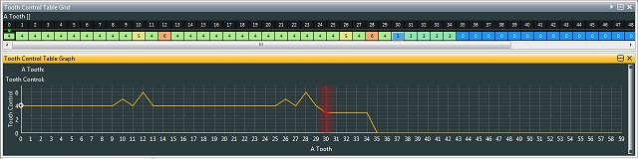

Sync Cam Count = OFF, Sync Crank S Count = OFF, Sync MX = ON
Sync Teeth = 1, MX Sync Test = 13 (15), MX Time = 75, Missing = 1, Test not Sync'd = On

Or if there is a conflict with a cam tooth.
Sync Cam Count = OFF, Sync Crank S Count = OFF, Sync MX = ON
Sync Teeth = 1, MX Sync Test = 13 (15), MX Time = 33, Missing = -1, Test not Sync'd = On

Example 7
Last Rover k series 12 5 10 4 as on 1st generation Lotus Elise, 36 teeth with 4 missing.
So: Tooth control table is quite complex, basically dividing by 3 (0 0 1) and skipping the missing teeth (1 0 1).
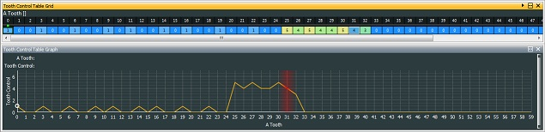
Note this gives rotation as anti-clockwise.
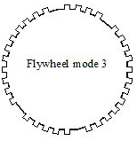Sync Cam Count = OFF, Sync Crank S Count = OFF, Sync MX = ON
Sync Teeth = 1, MX Sync Test = 3 (the value captured in MX Tooth No after the run of four teeth), MX Time = 5%, Missing = 1. Test Not Sync'd must be set to ‘On’, so that while cranking all opportunities are used for timing synchronisation.

Example 8
Old Renault (22-2) 40 crank teeth at 8.18 degree intervals on crank with 1 cam tooth.
So: The initial section acts as a divide by 11 so that internal tooth scaling is 1 tooth= 180deg, so Ignition Range = 0.5. The final section is looking for the missing teeth.
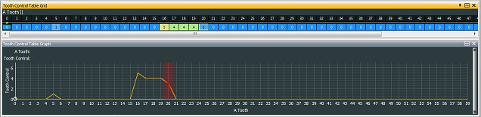
Sync Cam Count = OFF, Sync Crank S Count = OFF, Sync MX = ON, Sync Teeth = 1, MX Sync Test = 19, MX Time = 50%, Missing = 2. Test Not Sync'd must be set to ‘On’, so that while cranking all opportunities are used for timing synchronisation. Set option Crank Alt Fire to ‘On’ and choose a suitable cranking ignition, by placing a 2 in table. Set Options Wheel Teeth=4, Ignition Cycle Teeth=4 (wasted spark) and Fuel Cycle Teeth=8.

4. Sync Cam

If Sync Cam width = ‘On’ and Sync Crank Div = ‘On’.
When all other sync strategies are turned ‘Off’, then this option allows a timing strategy which ignores any tooth control table. The option Crank Divider will chop even crank teeth into internal teeth. The cam pulse width measured in crank teeth displayed by the parameter Cam Width. Sync'd if SS Tooth No = MX Sync Test (specified in ‘real’ teeth between missing teeth).

Example 1
Very old BMW M3
135 crank teeth on ring gear, one sync pulse at 1/2 engine speed.
Crank Divider = 9, giving 15 internal teeth per rev. 24deg/internal tooth
So Ign Range = 2.75, Fuel Cycle teeth = 30 Ign Cycle Teeth = 15 wasted spark.
MX Sync test = 30, Sync Cam Width = On Sync Crank Div = Off

Example 2
Nissan
360 ‘high speed’ (crank teeth) with 4 cylinder slots of different widths. This is equivalent to 2, 3, 4 or 5 crank teeth.
Crank Divider = 15, giving 12 internal teeth per rev. 30deg/internal tooth
So Ign Range = 3.0, Fuel Cycle teeth = 24 Ign Cycle Teeth = 12 wasted spark.
MX Sync test = 251, cam pulse width measured in crank teeth displayed by Cam Width, Sync Cam Width = On Sync Crank Div = On use only fast falling edges for crank (T1) and cam (T2).

Other Sync options and considerations

Sync off above will ignore the cam signal above a certain engine speed. This option is never applied if the value is set to ‘0’.

Sync Err R/S will disable Stat Sync'd if the stated number of Sync errors are detected. Also used as the number of good syncs to re-establish synchronisation.

Test Not Sync'd option allows setting the test for synchronisation, bit 2 in the tooth control table, at the critical points only or point for the sync'd condition, saving significant interrupt processing time.

Sync Test A Tooth and Sync Test A enable options to move cam synchronisation decision at an A Tooth, rather than synchronisation test at last valid entry in Tooth control table. This is very useful with variable cam control systems, where the cam signal used for synchronisation crosses the old fixed decision point. Only used with Sync MX.

