Setting up CAN Telemetry in '80' series GEMS ECUs

The '80' series GEMS ECUs, can have their CAN bus transmissions setup via the GWv4 calibration software. This can be actioned by selecting the 'Telemetry' tab at the top of the GWv4 workspace, once you have opened your calibration.....

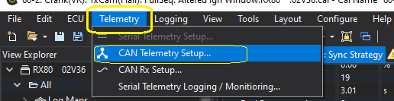

…. and then selecting the 'CAN Telemetry Setup' feature. This will then display a panel, where you can select the parameters that you wish to put onto the CAN bus, the CAN bus speed and the rate that you want to dispatch the packets of data in their defined arbitration codes. Below is an example panel, showing the 8 bytes of data that you can transmit in each message.
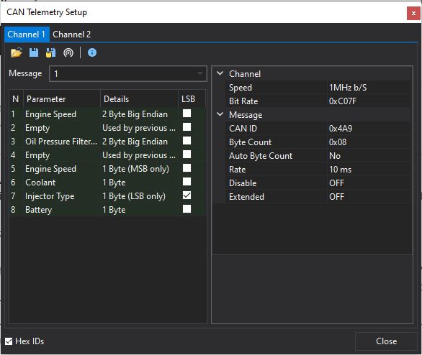
The important areas to notice, is that the left-hand side of the panel contains a list of parameters, while the right-hand panel controls the attributes of the messages on this bus. In the '80' series of ECU's there are two CAN 'ports', so you are able to connect the ECU to devices with differing CAN speeds. Which port you are configuring, is selected by the 'Channel 1' or 'Channel 2' tabs at the top of the panel. For this document, we will select 'Channel 1'.

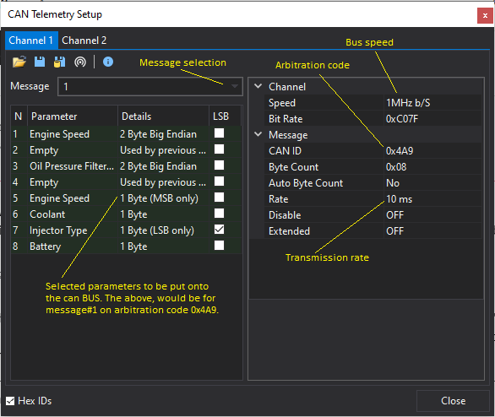

Working from the left-hand panel first, there is a drop down option titled 'Message'. This will allow you to select any one of the (up to) 8 messages that the port can handle. Each message will contain 8 bytes of data and depending upon the parameters being selected. This can be 8 x 1 'byte' parameters, 4 x 1 'word' parameters, or a mixture of the two. It is advisable to place 'words' on odd numbered bytes (1,3,5,7) as shown above. If only the 'Most Significant' or 'Least Significant' byte from a word is needed, it will be shown in the details and can be selected by flagging the appropriate parameter.

In the right hand panel, you can define the speed of the Channel, the arbitration code for the 8 bytes of data and the rate that the parcel of data gets transmitted on the bus. In the above example, code 0x4A9 is sending Engine Speed, Oil Pressure, Coolant, Battery and the type of Injector at a rate of 100 times a second at a transmission speed 1MHz bits per second. The Auto Byte Count, if set to 'ON', will automatically set the Byte Count to the number of bytes to be transmitted. If you need to send an extended arbitration code, set Extended to 'ON'.

Once you have selected 8 bytes of data and filled up 'Message#1', then by clicking on the drop-down box and selecting 'Message#2', you can add a further 8 bytes of data. Dependent upon the ECU you are using, you can have up to 8 messages, so 64 x 1 byte parameters, 32 x 1 word parameters etc.

