A testers guide to Auto Mapping

In the following document and test, three pre-test settings are assumed to be in place….
- The calibration has a working Lambda Feedback in operation.
- The Automapping only is controlling the fuelling. (Turn Lambda fuelling ‘OFF’)
- The [Lambda Log Map Target] grid should be populated with the required finishing values.

For simplicity sake in the following test, we are using a flat [Ox FB/Lambda Target] map, set to a value of 1.000 across the table.

The options as to how the auto-mapping is controlled, are set in the Lambda Log Map Control panel. This governs the depth and speed of the changes to be made in the fuelling map. There is a detailed explanation of how the individual options in this panel perform in the GWv4 ‘Help’ feature (see Log Map Controller in the Automapping section), but the following settings worked well in testing…

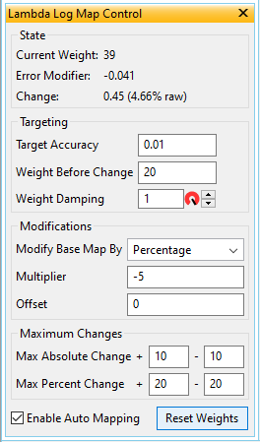
In this example, the values in the ‘State’ portion of the panel, are provided by the current cell detail in the [Fuel] grid and give some visual feedback on how the process is affecting the cell’s value.

The ‘Targeting’ portion, controls the requirements that need to be satisfied, before a cell’s value is to be considered for change.

‘Modifications’ control the way that the cell’s value is changed. For Lambda feedback, a negative value for the multiplier would usually be needed.

‘Maximum Changes’ control the overall amount of deviation from the original cells value.

An Automapping On/Off switch….
… and a reset to ‘0’ for the ‘Current Weight’ up-counter, which can restart the weight check on a cell.

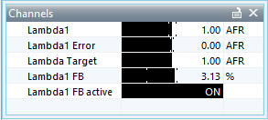
Prior to Automapping being enabled, with a cell selected for mapping, the current lambda value from that load/RPM cell will be shown in the Lambda1 parameter, the current target that the ECU will try to obtain will be in Lambda Target and the difference between these two, will be shown in Lambda1 Error. (These parameters maybe ‘OX…’ dependent upon the ECU)
Check that OX/Lambda Feedback is active.
When the Auto mapping is enabled for a particular cell (90% throttle and 5000 RPM in the example below), the ECU will now try to adapt the fuelling to match the reference from the [Lambda Log Map Target] grid. So in our example below, it will increase the fuelling in that particular cell, until the Lambda1 parameter reaches 0.954, and then the fuelling adjustment stops for that particular cell.
This is why Lambda feedback has to be active.

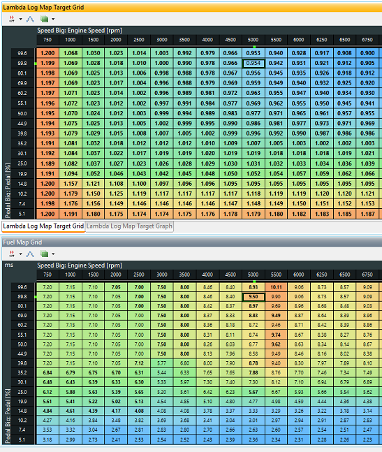

By varying the ‘Weight Before Change’ and the ‘Multiplier’, this can speed up or slow down the rate at which the changes take place. The more decimal places that you specify in the ‘Target Accuracy’ will also affect the rate. The values set in the Controller in the previous page are not that particularly fast but they proved to be accurate.

Once mapping is complete, the [Lambda Log Map Target] grid/map values needs to replace the original (Lambda Target] grid/map to match the newly mapped [Fuel] map.
Turn Lambda Fuelling back ‘ON’.

