LDS3R Quick Start Guide

Once that you have installed the LDS3R Editor software, you are ready to tailor the setup within the scope of the options available.

To start with, click on the Display tab and select ‘Show All’. This will allow you see all of the 8 default pages.

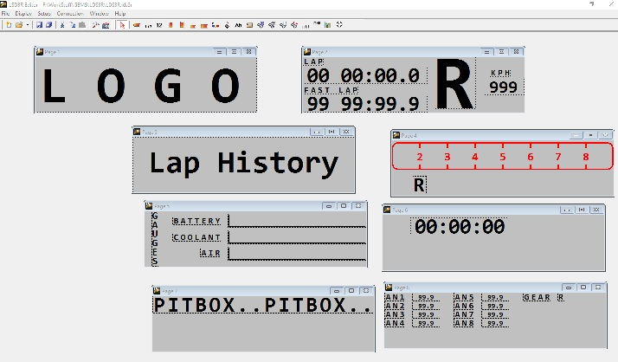

Next, move to the Setup tab, click on it and then select the top option ‘Edit’. This is where the most of the setup work is carried out, as it is here that all of the Inputs, Outputs, Sensors and Scalers are defined. Below, is shown the ‘Outputs’ tab, where the various parameters that are to be displayed can be defined.
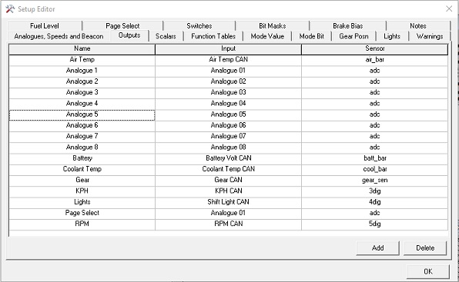
The ‘Input’ column, shows where the source data is to be received from, whether this be an Analogue input or off the CAN bus.

The ‘Sensor’ column, defines how the data is treated before it is passed to the ‘Name’ column for displaying. A sensor can be a Scalar, a Function Table or a BitMask and if you click on theses tabs, a table will be displayed that allows you to manipulate the input data in which fashion you need. A Scalar is a multiplier with upper and lower limits. A Function table allows a non-linear scaling to be carried out, while a Bit-Mask allows a selection of a ‘bit’ of data from a ‘word’ of data, supplied from the CAN.

The ‘Name’ column, specifies the name of the scaled input data and is used to define the parameter on the page.

The ‘Lights’ tab is where the LEDs are given their operating instructions. The trigger, colour and upper/lower limits are specified here.

The Page Select tab allows the calibration of a rotary switch, so that the eight pages can be selected. This is dependent upon the voltage supplied to the page select pin.

The LDS3R Settings panel, allows the setting of the Mode Switch, the Increment Switch and the Decrement switch. These are very flexible as any of the outputs, defined on the Setup page can be used here.

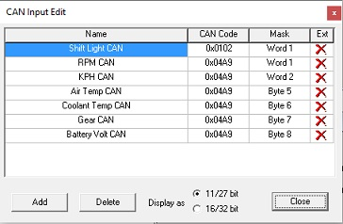
The Setup/Input/CAN option, is where you are able to specify the CAN ID codes and masks that contain the data that you want to display off the CAN bus.

The actual arbitration code is specified in the ‘CAN Code’ column, while the ‘Mask’ states the location of the data within the arbitration code.

If you are reading ‘Extended’ CAN IDs, the ‘Ext’ column needs to show this by changing the Red Cross (as shown in the panel above) to a Green Tick. . The Add and Delete buttons allow more codes to be added or removed from the page. Here, you can also specify if the data is ‘signed (‘+’ or ‘-‘) and whether the data is big or little endian.

Click the Close button (‘X’ in top right-hand corner) when you have finished adding codes to the received list.

You can also specify CAN messages that you want to send to another device, a DA3 Logger for example, in the Outputs/CAN Outputs facility (see below, next page). Here you would specify a new CAN ID and the frequency that you want to transmit it at.

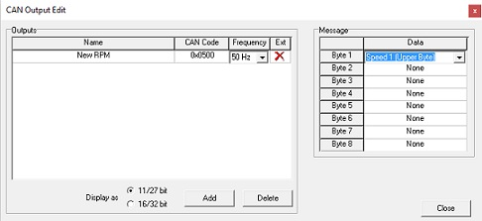

Lastly, in the Setup tab, is the CAN Speed facility, where you will select the CAN speed for the bus that you are using. The speeds available are 125KHz, 160KHz, 250KHz, 500KHz and 1MHz.

The Connection tab, ‘Connection Setup’ is where you select the port to be able to communicate with the LDS3R with the LDS3R Editor. This will usually be via a CAN editing tool, P-CAN for example. Select the appropriate port that the CAN interface tool is connected to and transmission baud rate from the list once you have connected the LDS3R to your PC/Laptop.

Note: The ‘Connection Setup’ will select the speed that the Editor will use to communicate with the LDS3R. The speed select in ‘Setup/CAN Speed’ will change the speed setting on the LDS3R. For example, if the LDS3R is set to 500k bit/sec, to change this speed to 1M bit/sec, go to Setup|CAN Speed and select 1M bit/sec. Under Connection Setup select 500k bits/sec. The LDS3R Editor will upload the new setup using the current speed of 500k bit/sec, then the LDS3R will change its bus speed to 1M bit/sec after reading the new setup. After it has been changed, future communications between the LDS3R Editor and the LDS3R should be done at the new speed (1M bit/sec in this case). The Connection Setup will update to the new speed to match the setup automatically after an upload has been performed.

The ‘Tools’ tab allow you to send the setup to an LDS3R display, check the installed firmware version and update/upgrade to a newer level of firmware.

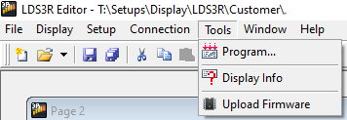

Finally, there is a tab called Windows that allows you to format the layout of the work space in the editor.

LDS3R Pin-out

