GEMS ethernet enabled ecus require the IP address to be automatically allocated.
This is the default setting for most computers so in most cases the ECU will be detected and connect without changing any settings. However if the settings are not correct you may need to change to get coms started.
Go to the network connections window either by searching Network connections or from the control panel. Click on the ‘Ethernet’ Icon…
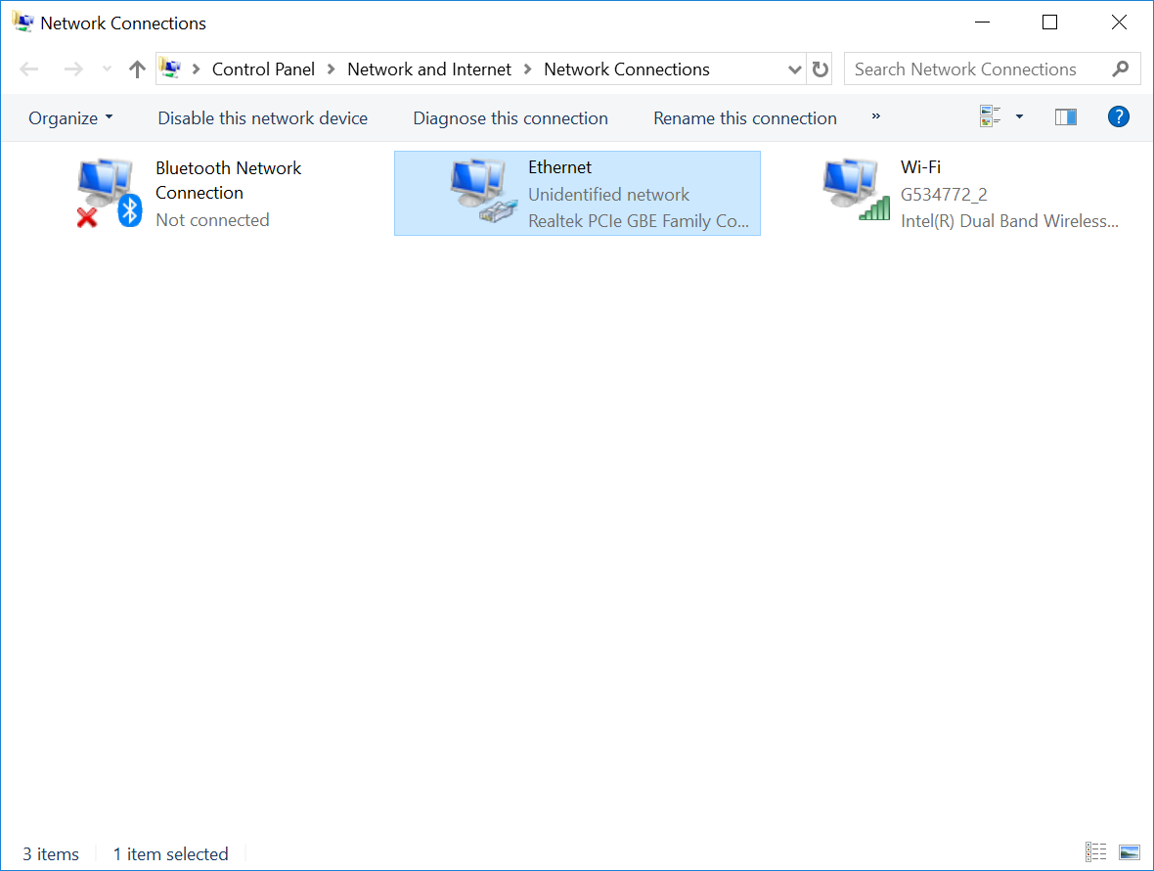

This will give the ethernet status click on ‘Properties’
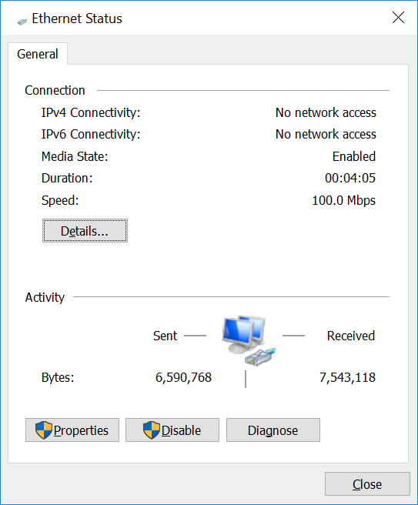
You should then see the following window.
Click on the Internet Protocol Version 4(TCP/IPv4)
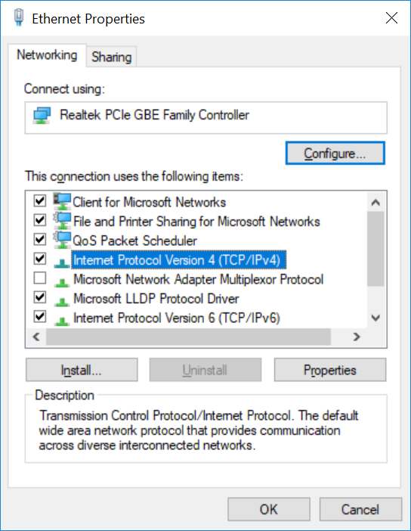
You will then see the following window…

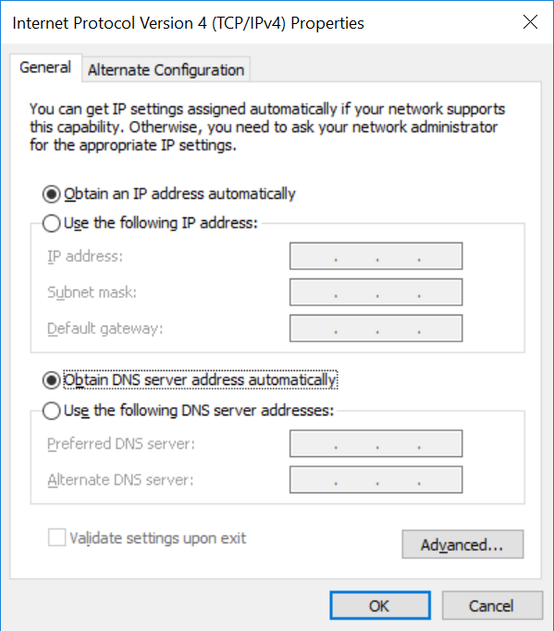
The “Obtain an IP address automatically” and “Obtain DNS server address automatically” options should be both selected and the 5 manual selection boxes should be empty.
If they are not empty click on the “Use the following option” and delete the contents and then reselect the “Obtain … Automatically” options.

Firewall settings
If coms is still not working especially if the ECU name is found in the GWv4 coms setup window
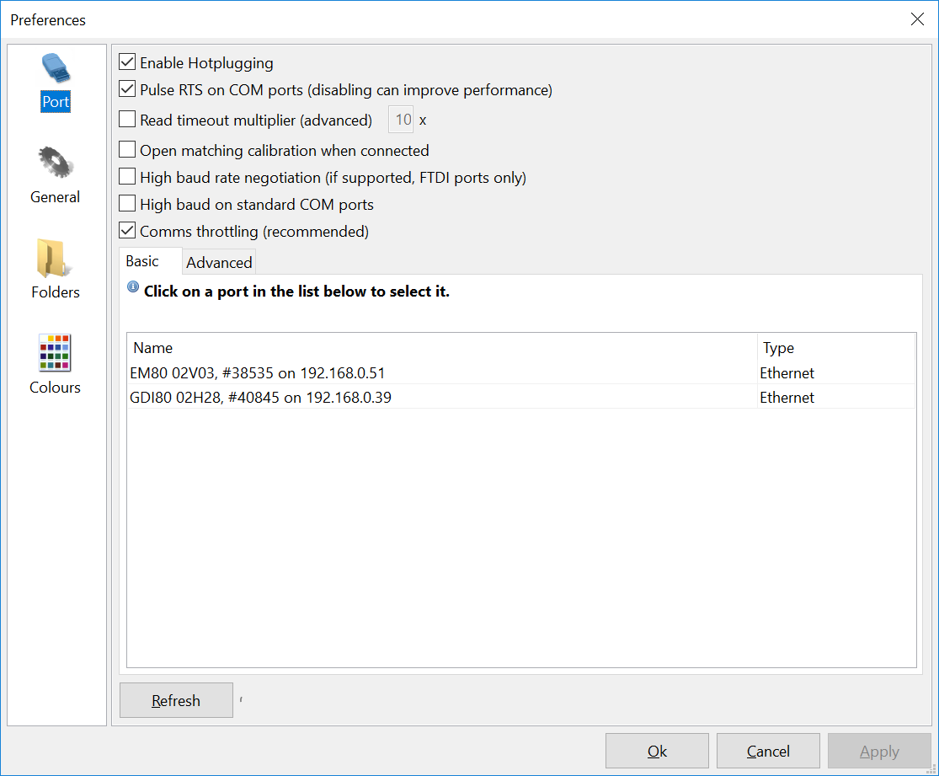
Then the Fire wall rules may need setting. These should be set by installing GWv4 but if there has been an update it may need resetting. The simplest method is to re install GWv4.
During the install, if you are asked to allow GWv4 in the firewall then “Agree”.



