Track/Stage maps from GPS
For many data analysis tasks, a map of the track or stage is a valuable commodity.

In order to construct a track map, there are some of prerequisites in terms of the channels you will require.

The first of these is that you'll probably need a distance channel.

If you are generating a GPS map, you'll need latitude and longitude channels. You should ensure that these channels have their units correctly specified, because they need to be internally converted to radians. The analysis software currently expects latitudes and longitudes that are referenced to the WGS-84 datum. Typically, commercial GPS units will provide coordinates with such a reference (and generally, they also use EGM-96, which gives Mean Sea Level altitudes, though that is not an issue here).

GPS track maps have the benefit that they can be exported to KML format for viewing in applications such as Google Earth.

A distance channel is not explicitly required for GPS track maps, though it is useful for being able to display your position on the track. See the Distance Channel section of the GDA (Pro) manual on how to set this up using the ‘maths’ functions.

If you have a lateral g or a yaw channel in addition to a speed channel AND a distance channel, then a track map can also be derived plotted. Bring up the track editor from the Data | Track Setup... menu. Alternatively add a track view to the current tab and click in the small spanner icon in its title bar and then click the Edit... button. The track editor should be able to calculate your track if you give it appropriate input channels.

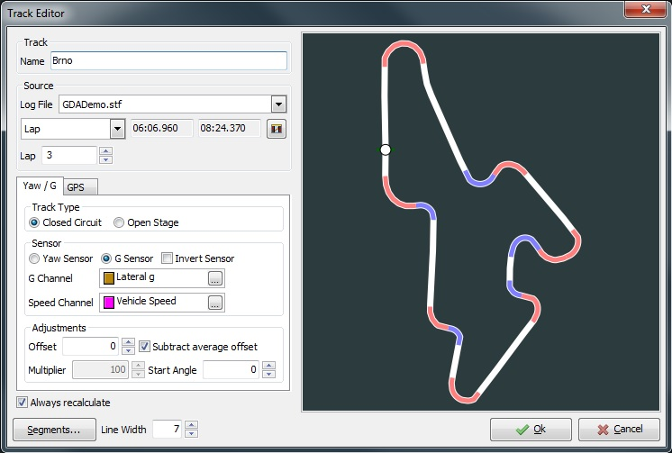

Track Map from Yaw / G
In this case, we have provided a 'Lateral g' channel and an average wheel speed channel that has been calculated using a maths channel. Note that we've told it that it is a 'g' sensor and not a 'yaw' sensor (gyro) because the calculations for these different types of sensor are subtly different.

'Invert sensor' will imply that the yaw/g sensor actually gives negative values for positive yaw/g. i.e. it will cause the values to be negated in the track calculations, and will cause the track map to be mirrored in a non-superimposable way.

The fastest lap has been selected as the reference lap by default so we don't need to change anything here. This might need changing if for some reason there is an additional lap beacon during your out / in lap resulting in an erroneous fastest lap. Or perhaps the fastest lap was due to the driver completely cutting out a chicane in which case an alternative lap may give a more representative racing line. Note: you can resolve any lap designation errors by editing the markers if necessary.

You can tweak a couple of parameters used in the track calculation to approach a more accurate representation of the track:

· | Offset  Adds or subtracts a constant value form the yaw/g and will have the effect of bulging/pinching the track. This is mainly required due to the fact that 'g' sensors and gyros often have a fixed offset error.

· | Subtract Average Offset  Estimate the sensor offset value and adds it to 'Offset'.

· | Multiplier  Multiplied with the yaw/g value before the offset value is added.  The multiplier is not adjustable in 'Closed Loop' mode because it has no visible effect (it is cancelled out by the algorithm that ensures the track ends line up).

· | Start Angle  Rotates the track map to a more aesthetically pleasing angle. Or so that north is up.

The offset and multiplier values are simply a linear transformation that is applied to the yaw/g sensor to account for errors - usually no two sensors are exactly the same and will require calibration. Once you have configured your track, you may add some segment highlights to it.

Rally Stage from Yaw / G
If you are using this on a rally stage and consequently do not have 'laps' then you'll need to do a little more tweaking. Ideally you'll have some GPS data to hand for the stage, but in the absence of such technology you may need to rely on a calculated track. You will want to make sure that you have accurate speeds of possible so as to avoid warping the map - especially in low grip conditions.

Start off by setting the Track type to 'Open Stage' and selecting your channels. The 'closed circuit' mode makes generating such tracks easier because the angular changes can be automatically warped to ensure that the circuit is always closed. You'll probably need to adjust the offset and multiplier to get something that looks sensible (see the above sections for further details on the parameters). Once you have configured your track, you may want to add some segment highlights to it.

Track / Stage Map from GPS
The GPS tab allows you to configure the track map to use GPS data instead of deriving the track from speed/g/distance. A distance channel does not have to be available to generate the GPS map. If it is available, then it will be used as a more accurate measure of distance travelled.

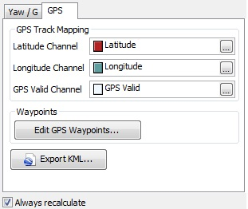

GPS Track Settings

All that is needed is for the latitude and longitude channels to be assigned and GPS track mapping to be enabled. The channels are interpreted as Radians, by default, so if your channels are not in these units, you should specify the units in your setup.

To get a decent GPS track map, you may need to do some additional preparation to your raw GPS data to account for loss of fix and other transient glitches which can otherwise lead to wildly incorrect maps.

You can add points of interest and way-points to the GPS track map by using the 'Edit GPS Waypoints' button. These are purely informational and do not influence the track generation at all - but they can be useful in checking that the track map is sensible. To view the map in an external program (e.g. Google Earth), use the "Export KML" button to store it in a file, using the Keyhole Markup Language (KML) format.
Once you have configured your track, you may want to add some segment highlights to it.

