EM36 Active Throttle

A pair of PWM outputs (PWM2 and PWM4) are used to control an active throttle. 2 split tables are used to control the PWMs. This new strategy has NO integral term and is simple and safer than previous versions.

1st a target position is made.
Act T Target table, below right, holds the desired target position for the active throttle versus the user selected demand input, selected by address option Act T Demand In. This signal is then scaled over its useful range by options Act T Demand min and Act T Demand max, below left, creating parameter Act T Demand. This is applied to Act T Target table, or if anti-lag mode is active, then a separate table Act T ALS Target table is used so that throttle is never fully closed.

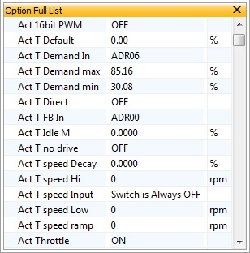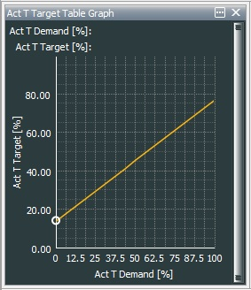

How to set options Act T Demand min and Act T Demand max, where demand is applied to 2nd MAP input.

No pedal demand: Act T demand min = (MAP2 raw in)/256 (100%) -0.3%

Full pedal demand: Act T demand max = (MAP2 raw in)/256 (100%) +1%

The difference between parameter Act T Target and the input from channel address, specified by option Act T FB In, is shown in parameter Act T Error.

This is submitted to the 2 paired tables: Act T Error-1/Act T Error+1 and Act T Error-2/Act T Error+2. Note. These paired tables effectively have a positive and negative zero error condition. These signals are driven out to the full bridge driver that controls the throttle.

